*JGR: Earth Surface*

Supporting Information for

**Controls on weathering zone thickness in a rapidly eroding mountain range, western Southern Alps/Kā Tiritiri o te Moana, Aotearoa-New Zealand**

A. Eger1*, M.J. Winnick2, I.J. Larsen2, L.M. Condron3, G. Boitt3, S.A. Hynek4, M.J. Jercinovic2, J.M. Rhodes2

1Manaaki Whenua – Landcare Research, Department of Soils and Landscapes, 54 Gerald St, Lincoln 7608, New Zealand

2University of Massachusetts, Department of Earth, Geographic and Climate Sciences, Amherst, MA 01003-9297, USA

3Lincoln University, Department of Soil and Physical Sciences, PO Box 85084, Lincoln 7647, New Zealand

4Pennsylvania State University, Department of Geosciences, 116 Deike Building, University Park, PA 16802, USA

*Corresponding author, egera@landcareresearch.co.nz

**Contents of this file**

Text – Supporting information on methodology

Figures S1 to S4

Tables S1 to S6

Supporting references

**Supporting information on methodology**

*Mineralogical analysis*

First, full thin section compositional maps were generated to establish phase textures. These maps were collected by stage raster at 15kV, 100nA, 10 micrometer beam diameter, 30 ms pixel count time and 35 micrometer pixel (step) size. Acquired elements were collected in two rounds, first for Na (Kα), Fe (Kα), Ca (Kα), Mg (Kα), and Si (Kα), followed by P (Kα), Ti (Kα), K (Kα), Al (Kα), and S (Kα). Each round consisted of peak and background acquisitions, with background intensities acquired at appropriate off-peak wavelength positions. Quantification was done by subtracting background map counts from the peak intensity map pixel by pixel, then computing k-ratios using appropriate standards, and arriving at oxide weight percent values using the PAP method (Pouchou and Pichoir, 1984) for matrix effects. In this way, each map pixel was fully quantified. Oxide weight percent maps were then used to generate a composite RGB image for differentiating phases. Phase modes were then extracted in Peaksight with Cameca’s phase-class software option which results in an average composition for each defined phase, along with the area percentage of that phase in the map. Phase class compositions could then be generated directly from maps by sampling pixels in the RGB maps (Figure 3 in main text). These compositions were checked and refined by running direct quantitative analyses on the defined phases.

*Phosphorus fractionation method*

The method follows Condron et al. (1996) and involves a sequential extraction of six consecutive steps on the same sample: 1) soil (PiNH4Cl) extracted with 1 M Ammonium chloride; 2) inorganic and organic P (Pibic and Pobic) with 0.5 M sodium bicarbonate (NaHCO3 at pH 8.5); 3) inorganic and organic P (PiOH_I and PoOH_I) with 0.1 M sodium hydroxide; 4) apatite P (PiHCl) with 1 M hydrochloric acid; 5) a second extraction with 0.1 M NaOH (PiOH_II and PoOH_II); and a final digestion with concentrated H2SO4 and 30% H2O2 to yield the residual P (Olsen and Sommers, 1982). The inorganic P concentration in acid extracts was quantified following Murphy and Riley (1962). Inorganic P in alkaline extracts followed Dick and Tabatabai (1977), whereas the organic P was obtained by the difference between the inorganic P and total P concentrations after digestion with ammonium persulfate and H2SO4 in an autoclave. Total P is equal to the sum of all extraction steps. All final extracts were analysed via ICP-OES. We also present the sum of the NH4Cl and NaHCO3 extractions of Al and Fe, which represent the labile/exchangeable fractions of these metals. Metal-associated P is the sum of all inorganic P extracted by NaOH and the residual P.

*River water sampling*

To retrieve the water samples, the sampling bucket was rinsed three times with river water before a sample was taken. All samples were filtered using sterile syringes with 0.45 µm nylon syringe filters (VWR, Radnor, USA). The subsamples for cation analysis were acidified with ultra-pure nitric acid. Samples were stored in acid-washed LDPE bottles for no longer than 3 months in a refrigerator until analysis. Samples were collected on 31/01/2015 and 01/02/2015 before, during, and directly after a rain event and thus representing hydrological conditions of baseflow, rising and falling limb.

*Reactive transport modelling*

Dissolution and precipitation reactions in our model are represented by Transition State Theory-style rate laws (Lasaga, 2014), where net rates are expressed as,

$R_{net }=k∙SA∙\left(\frac{Q}{K_{eq}}-1\right)$ (equation 1)

where *Rnet*is the net reaction rate (dissolution is negative, and precipitation is positive), *k* is an intrinsic rate constant (mol m-2 s-1), *SA* is the reactive mineral surface area (m2), *Q* is the ion activity product, and *Keq* is the equilibrium constant for the given reaction. The (Q/Keq-1) term is a linear representation of reaction affinity, such that net reaction rates go to zero as the reaction approaches thermodynamic equilibrium. In addition to mineral dissolution/precipitation reactions, we also include inorganic carbon, aluminum, and phosphate speciation reactions through the specification of secondary species. Kinetic rate constants and activation energies are taken from Palandri and Kharaka (2004), and thermodynamic data from the EQ3/EQ6 database (Wolery et al., 1990) and Arnorsson and Stefansson (1999).

**Supplementary figures and tables**

Figure S1. Examples of rock core samples at time of extraction. The grey-coloured bulk schist is interspersed by weathered rock and quartz veins. The red rectangles in A and B indicate sampling locations of weathered, incoherent rock at 49.0 m (A) and 63.2 m (B); in C the sampling interval containing the quartz-calcite vein at 250.0 m is shown (Photos: Alton Drilling, Geotech Consulting).

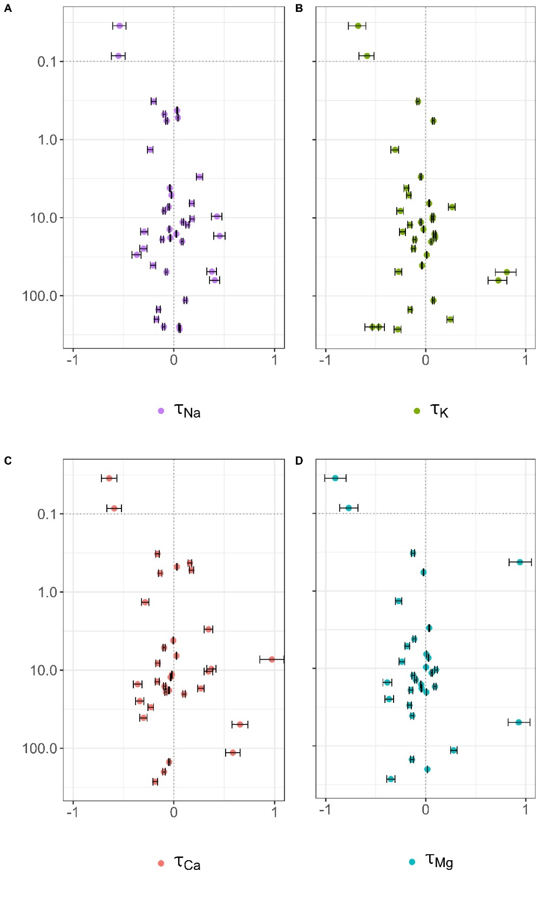

Figure S2. Results of the mass balance calculations as presented in Figure 2 (panels E-G) but with uncertainties (95% confidence interval) as derived from bootstrapped medians. Note that the confidence intervals are not symmetrical due to the skewness of the distribution of the bootstrapped medians and increase with the absolute τ values. Expressed as fractional uncertainty, the absolute uncertainties correspond to 12-15% relative uncertainty of the final τ values due to the variability of the medians of the rock reference.

Figure S3. Plots of solute concentrations in the Hokitika River for various elements and levels of discharge (Q). Our data are similar to that of Lyons et al. (2005) for major elements (Ca, Na, Si), showing a dilution effect as discharge increases (first row). Lyons et al. (2005) did not report values of Al, Fe or Mn, but for these elements our data show increases in concentrations at higher rates of discharge (second row). For context, at this point of the river, the annual median flow is ~61 m3 s-1, and the mean annual flood flow is ~3100 m3 s-1 (<https://www.lawa.org.nz/explore-data/west-coast-region/water-quantity/surface-water-zones/hokitika/hokitika-rv-gorge>).



Figure S4. Sensitivity analysis of the effect of sulfuric acid weathering on the carbon exchange budget within the range of soil production rates typical for our study area. At a 0.4 mm y-1 soil production rate, a pyrite concentration of only 0.5% is necessary to negate the carbon drawdown effect of silicate weathering.

Table S1. Rock core chemical data. See supplementary tables (xlsx file) and <https://doi.org/10.7931/en0s-5j70> (Eger et al., 2025).

Table S2. Hokitika River water chemistry. See supplementary tables (xlsx file) and <https://doi.org/10.7931/en0s-5j70> (Eger et al., 2025).

Table S3. Reaction network and rock composition at start of the ChrunchFlow simulation. See supplementary tables (xlsx file) and <https://doi.org/10.7931/en0s-5j70> (Eger et al., 2025).

Table S4. Parameters used to calculate the carbon (C) exchange budget.

|  |  |  |  |
| --- | --- | --- | --- |
| Parameter | value | unit | reference |
| bedrock denudation rate/soil production rate | 0.4 | mm y-1 | Larsen et al. (2014) |
| bedrock bulk density | 2.65 | g cm-3 | Larsen et al. (2014) |
| factor for converting bedrock denudation/soil production into topsoil denudation rate | 5 | - | See main text for details |
| chemical depletion fraction (CDF) | 0.2 | - | Larsen et al. (2014) |
| total Ca | 1.77 | % | this paper |
| carbonate Ca | 0.22 | % | this paper |
| total Mg | 1.08 | % | this paper |
| petrogenic C | 0.08 | % | this paper |
| Soil organic C stocks (0-10 cm) | 2095 | Mg km-2 | Natural Forest Survey (McNeill et al., 2014), see Table S5 |
| flux of landslide-mobilised C reaching the rivers | 2.2 | Mg km-2 y-1 | Hilton et al. (2011) |
| burial factor of terrestrial C | 0.5 | - | Hilton and West (2020) |

Table S5. Mineral phases (%) of the schist at various depths using microprobe analysis.

|  |  |  |  |  |
| --- | --- | --- | --- | --- |
| **Depth (m)** | **1.35** | **7.30** | **11.40** | **250.00** |
|  |  |  |  |  |
| actinolite | n.i. | n.i. | n.i. | 35.02 |
| andesine | 44.02 | 16.37 | n.i. | 37.95 |
| apatite | 0.19 | 0.02 | 0.06 | 0.22 |
| biotite | 9.41 | n.i. | n.i. | n.i. |
| biotite and/or hornblende | n.i. | 3.86 | 10.95 | n.i. |
| calcite | n.i. | 0.92 | n.i. | 9.06 |
| Fe-oxide | n.i. | 0.01 | n.i. | n.i. |
| garnet | 0.4 | n.i. | n.i. | n.i. |
| ilmenite | 0.07 | n.i. | 0.02 | 3.07 |
| muscovite | 10.44 | 7.82 | n.i. | n.i. |
| oligoclase | n.i. | n.i. | 44.68 | n.i. |
| pyrrhotite | n.i. | n.i. | n.i. | 0.5 |
| quartz | 29.39 | 53.76 | 33.33 | 13.03 |

n.i. not identified

Table S6. Plot locations, vegetation communities, and associated soil carbon stocks used in our analysis, obtained as part of the Natural Forest Survey (McNeill et al., 2014).

|  |  |  |  |  |  |
| --- | --- | --- | --- | --- | --- |
| Plot_ID | Latitude | Longitude | Vegetation community | Vegetation class | Soil C (0-10 cm, Mg ha-1) |
| AB139 | -43.9739 | 169.036 | *Weinmannia racemosa – Prumnopitys ferruginea – Dacrydium cupressinum / Blechnum discolor forest* | Natural forest | 10.5 |
| AU125 | -42.9819 | 170.9482 | *Weinmannia racemosa – Prumnopitys ferruginea – Dacrydium cupressinum / Blechnum discolor forest* | Natural forest | 27.2 |
| AV124 | -42.9453 | 171.0643 | *Weinmannia racemosa – Prumnopitys ferruginea – Dacrydium cupressinum / Blechnum discolor forest* | Natural forest | 37.7 |
| AV125 | -43.0127 | 171.0844 | *Weinmannia racemosa – Griselinia littoralis – Pseudowintera colorata / Blechnum discolor forest* | Natural forest | 16.4 |
| AW123 | -42.9089 | 171.1697 | *Weinmannia racemosa – Griselinia littoralis – Pseudowintera colorata / Blechnum discolor forest* | Natural forest | 25 |
| Z140 | -44.0384 | 168.8316 | *Weinmannia racemosa – Griselinia littoralis – Pseudowintera colorata / Blechnum discolor forest* | Natural forest | 8.9 |

**Supporting references**

Arnorsson, S., Stefansson, A., 1999. Assessment of feldspar solubility constants in water in the range of 0 degrees to 350 degrees C at vapor saturation pressures. American Journal of Science 299, 173.

Condron, L.M., Cornforth, I.S., Davis, M.R., Newman, R.H., 1996. Influence of conifers on the forms of phosphorus in selected New Zealand grassland soils. Biology and Fertility of Soils 21, 37-42.

Dick, W.A., Tabatabai, M.A., 1977. Determination of orthophosphate in aqueous solutions containing labile organic and inorganic phosphorus compounds. Journal of Environmental Quality 6.

Eger, A., Winnick, M. J., Larsen, I. J., Condron, L. M., Boitt, G., Hynek, S. A., et al. (2025). *Supporting Information for: Controls on weathering zone thickness in a rapidly eroding mountain range, western Southern Alps/Kā Tiritiri o te Moana, Aotearoa-New Zealand*. Retrieved from: https://doi.org/10.7931/en0s-5j70

Hilton, R.G., Meunier, P., Hovius, N., Bellingham, P.J., Galy, A., 2011. Landslide impact on organic carbon cycling in a temperate montane forest. Earth Surface Processes and Landforms 36, 1670-1679.

Hilton, R.G., West, A.J., 2020. Mountains, erosion and the carbon cycle. Nature Reviews Earth & Environment 1, 284-299.

Larsen, I.J., Almond, P.C., Eger, A., Stone, J.O., Montgomery, D.R., Malcolm, B., 2014. Rapid Soil Production and Weathering in the Southern Alps, New Zealand. Science 343, 637-640.

Lasaga, A.C., 2014. Kinetic Theory in the Earth Sciences. Princeton University Press, Princeton.

Lyons, W.B., Carey, A.E., Hicks, D.M., Nezat, C.A., 2005. Chemical weathering in high-sediment-yielding watersheds, New Zealand. Journal of Geophysical Research: Earth Surface 110, F01008.

McNeill, S.J.E., Golubiewski, N., Barringer, J., 2014. Development and calibration of a soil carbon inventory model for New Zealand. Soil Research 52, 789-804.

Murphy, J., Riley, J.P., 1962. A modified single solution method for the determination of phosphate in natural waters. Analytica Chimica Acta 27, 31-36.

Olsen, S.R., Sommers, L.E., 1982. Determination of available phosphorus, in: Page, A.L., Miller, R.H., Keeney, D.R. (Eds.), Method of Soil Analysis. American Society of Agronomy, Madison, WI, p. 403.

Palandri, J.L., Kharaka, Y.K., 2004. A compilation of rate parameters of water-mineral interaction kinetics for application to geochemical modeling [electronic resource] / by James L. Palandri and Yousif K. Kharaka ; prepared in cooperation with the National Energy Technology Laboratory, United States Department of Energy. U.S. Dept. of the Interior, U.S. Geological Survey, Menlo Park, Calif.

Pouchou, J.L., Pichoir, F., 1984. A New Model for Quantitative X-ray Microanalysis, Part I: Application to the Analysis of Homogeneous Samples. La Recherche Aerospatiale 3, 167-192.

Wolery, T.J., Jackson, K.J., Bourcier, W.L., Bruton, C.J., Viani, B.E., Knauss, K.G., Delany, J.M., 1990. Current Status of the EQ3/6 Software Package for Geochemical Modeling, Chemical Modeling of Aqueous Systems II. American Chemical Society, pp. 104-116.